# **DDOS ATTACK**

DDOS ATTACK

In order to make a server inaccessible to other users, we will be using Metasploit in this experiment to bombard it with requests. To achieve this, we will require an IP address, which we may obtain by using the previously discussed scanning techniques or honeypot.

For the purposes of this experiment, let's suppose that I wasn't happy with how Apple designed the new iPhone. The IP address I was able to get using Pingplotter for Apple is currently 17.253.144.10; when we open Metasploit, we see this:

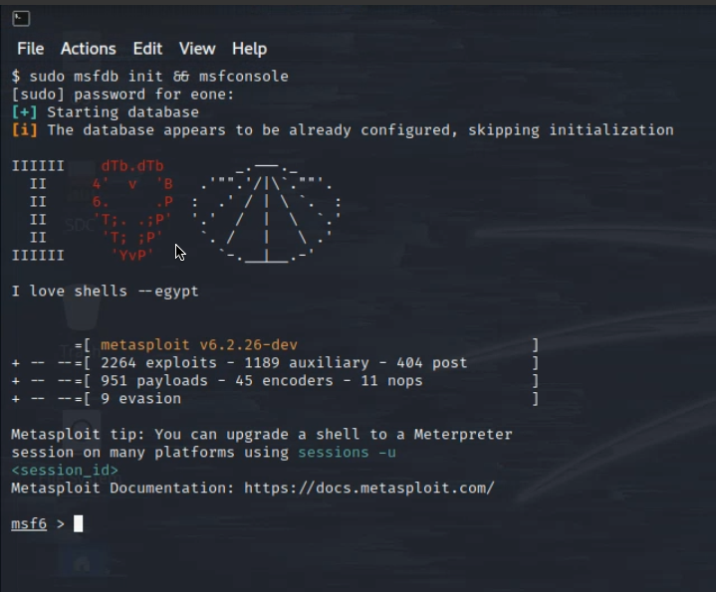

Here we follow what the Doccument says: Then use the select the auxiliary “auxiliary/dos/TCP/synflood” by typing the following command. Msf6 > use auxiliary/dos/tcp/synflood Msf6> show options.

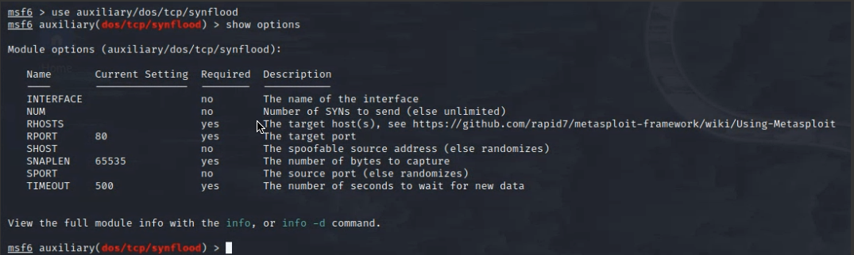

And we follow buy inputting our IP address of choice, in this case apple's in the host section and then we type exploit, here's what we get:

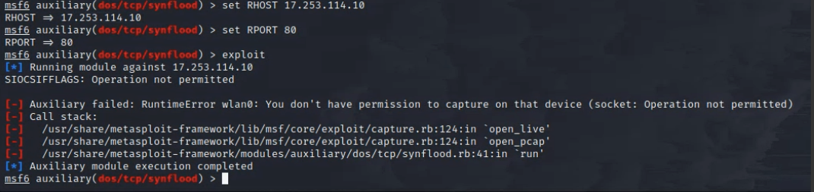

Unfortunately, we encounter an error here. Upon investigating the cause, it appears that my OS configuration is to blame. Since I installed Kali directly on my hard drive—rather than using a virtual machine—Kali does not recognise my wireless LAN adapter and/or does not want to use it. Nevertheless, ever since I attempted to get this to work in class, it has refused to cooperate. We know the expected result of this and the cause, though: professional cybersecurity users always advise using a machine that Kali recommends, and they also advise using desktop computers over laptops due to superior driver support. This error concludes our experiment.

Since there is just one node bombarding the website with requests, if this had worked, it would not have disrupted the Apple website. My IP would most likely be marked for a few hours or days.

If the experiment is successful, we will also be able to view the traffic that is being sent from our device to the website that we are targeting. However, as we observed in class from the wireshark logs, this will ALSO disrupt your own network, making everything extremely slow.